Antioch Church of Christ
Summer Intern Overview

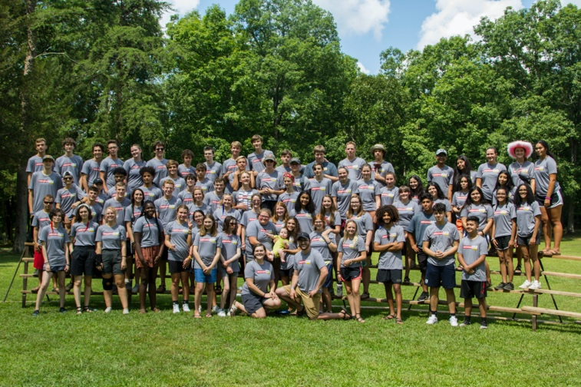
Antioch Youth Ministries

The Church
Antiochcofc.org

Antioch Church of Christ is located in Antioch, Tennessee, right outside Nashville. We are a church of about 500 regular members who look to serve God and our community. In short, we strive to be a church that makes a difference in each other’s lives and the lives of others. Antioch is staffed by:

Elders: Ministers:
Todd Bess Patterson Morgan--Preaching
Stephen Bridges Andrew Sowards—Executive
Jim Hodge Jonathan Parker—Youth (High School)
Kent Johnson Chuck Chisam—Youth (Middle School)
Benton Lowe Bridget Lindsey—Children’s
Ronnie Martin Jose Nieto—Community
Wayne Russell Steve Diggs--Financial
Jim Thweatt Jo David Keith—Worship
Todd Wigginton
Michael Whittington

Staff:
Tanya Lowe- Receptionist
Barbara Biffle- Support Staff
Elaina Marshall- Youth Ministry Assistant
Pamela Gonzalez- Support Staff

The Youth
Antiochcofc.org

The Antioch Youth Ministry (AYM) is made up of Birth-12th Grade. We have about 50 kids birth-4th grade, 25 middle schoolers (5th-8th grade), and 40 high schoolers (9th-12th grade). Our youth ministries strives to love God and love others. We do this through, Wednesday Night Worship, Hang outs, Mission Trips, Service Days, Retreats, and more!

Ministry Expectations
· Maintain your own spiritual walk and witness through continual prayer, study, and meditation
· Assist youth ministry leaders in areas of ministry, being quick to utilize your personal spiritual strengths.
· Avoid situations in which you may find yourself alone with a minor. All Interns must complete the Background Check before working with minors.
Ministry Responsibilities:
· Help teach Children’s, Jr. High, and or High School classes throughout the Summer in conjunction with the AYG’s topics and curriculum.
· Continually utilize all available communication methods used by the AYG.
· Help coordinate weekly gatherings/ activities (including communication, transportation, logistics, adult sponsors, etc)
· Assist with Antioch’s “Fusion” as needed.
· Coordinate and assist with youth trips such as:
High School Mission Trip/Trek
ABC- Summer camp
Mid-Western Children’s Home Mission Trip
And any other overnight trips.
· Be present at all scheduled AYG functions (hang outs, bible class, weekly events, etc)

Time Commitment

· Interns are to report to Antioch COC on Sunday Morning, May 21st, 2023. The job starts this morning.
· The internship ends Sunday night, July 30th, 2023 (10 weeks total).
Any time off that is needed for special events such as weddings, etc, is to be planned with JP before the internship is offered and accepted.
Each intern is expected to be on time at the times that JP delegates for office hours and youth activities.
Interns will take the day that JP takes as his day off.
We will take days and times off appropriately according to what the schedule allows.

Salary, Compensation, Transportation and Housing

· Each intern will make $317/weekly for 10 weeks. ($3,174).
· Each intern must provide their own means of transportation while in Antioch/Nashville.
· You will be able to take ONE full weekend off during the summer. Friday, Saturday, and Sunday.
· Each intern will be provided a certain sum of money for food on youth trips. All receipts and change must be returned to JP.
· Each intern will have a spending allowance for treating teens with a coke or ice cream. This allowance amount will be disclosed at the beginning of the internship.
Gas will be paid for the trip down to Antioch to start, and the trip back home after the summer is over. Give all receipts to JP.
Each intern will be provided an Antioch family to live with for the summer. The family will have the opportunity to provide some of the intern’s meals. Youth families will also have the opportunity to sign up to “feed the interns” on days that are specifically assigned by JP.
Each intern is to maintain a good relationship with their host family. They are expected to be neat, thoughtful, and helpful while staying in their summer residence.

Attitude and Behavior

· The intern is to model godly behavior and a Christ-like servant attitude at all times.
· The intern is to use much discretion in relating to young men/women. No flirting with or dating youth group members or fellow interns is allowed during the internship.
· The intern is to always be supportive of current youth programs, plans and activities. They should maintain a joyful and cheerful appearance and be excited!
· The intern is to maintain a good working relationship with JP and the rest of the staff.
· The intern must agree that: Drugs, alcohol, unholy speech (swearing, slander, dirty jokes, etc.), and any sexual interaction will be grounds for dismissal.

Oversight and Supervision

· The intern will work under the oversight of the Antioch Church of Christ elders and specifically under the supervision of JP.

I understand the failure to comply with these requirements will be considered a breach of this agreement, and grounds for immediate dismissal. I agree to abide to the contents of this job description and will do my best to fulfill my obligations as a youth intern for the Antioch Church of Christ.

Please feel free to email me or call me with any questions.

To Apply, please send your resume, and references to Jonathan Parker (JP): jp@antiochcofc.org

405-531-7456
jp@antiochcofc.org

