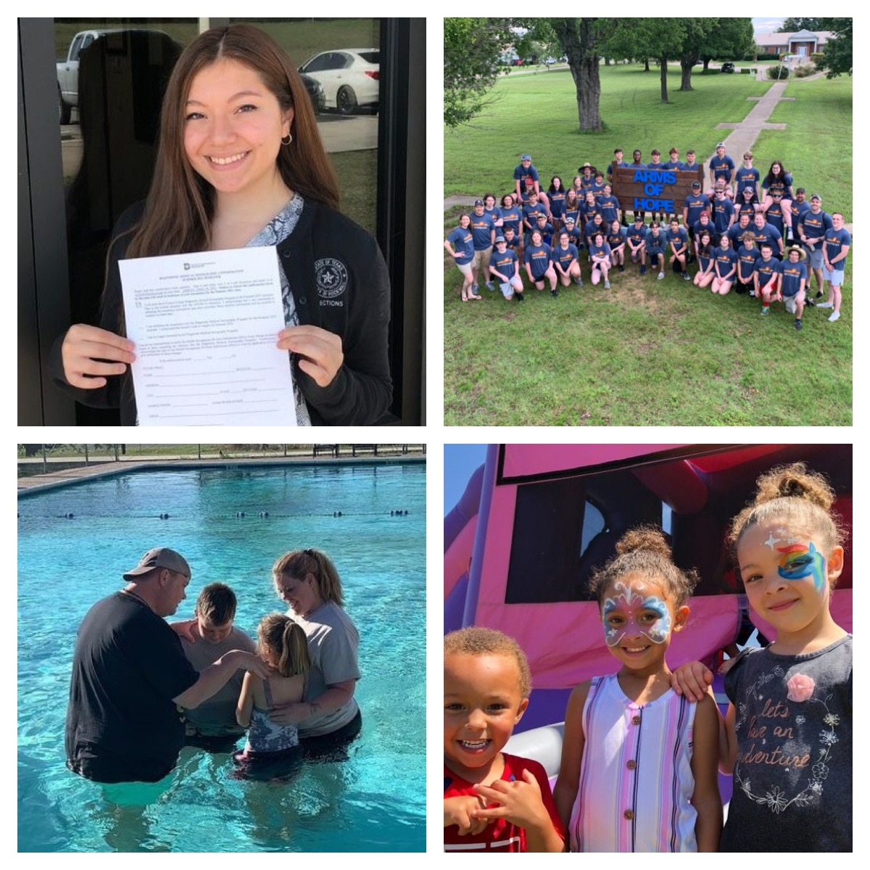
Arms of Hope
Arms of Hope is seeking smart, engaging, and motivated individuals to join our campus communities (Medina Campus & Boles Campus) as summer interns. The internship opportunity will provide valuable life and work experiences under the supervision of the Director of Ministries. Responsibilities will include but are not limited to: assisting in campus ministry, organizing/planning events, assisting with volunteer group activities as well as helping with other social services summer programming. Interns will be involved in multiple camp like experiences to include: Wilderness Expeditions, youth camps, and family camps. The internship requires a flexible, summer long commitment that could last between 8-12 weeks.

Job Description:
Expected to professionally complete summer work assignments; interns will learn to work in a variety of ministry and basic level child care experiences. Day to day tasks will vary greatly from volunteer groups, to residential care children, to college & career, and to our single mother’s program. Whatever the task, interns will have an opportunity to make a significant difference to the entire campus community which is comprised of residents, volunteers, and staff. Candidates must be a believer in Jesus Christ, spiritually mature, and grounded in their faith, as well as an understanding of the importance of modeling strong values and moral character.

Requested Skills and Experience:
- Currently attending (or recently graduated) an accredited college or university.
- Available to work flexible hours – minimum 40 hours per week.
- Able to commit to the entire summer.
- Able to complete all assignments made by supervisor.
- Must have strong interpersonal skills.
- Have a level of professionalism when dealing with staff and residents.
- Excellent verbal and written communication skills.
For more information please contact:
Matt Anderson – Director of Ministries (Boles Campus)
manderson@armsofhope.org
903-224-4908

- Have the ability to work well with a team as well as complete individual tasks.
Benefits:
- Paid Position
- Commissary privileges
- On campus housing
- Real life work experience and responsibility
- Opportunity to minister to youth, single mothers, staff, and volunteers.
- A life changing experience.

